1. Have a upload feature to upload the .xls , .xlsx feature.
2. To be able to choose just a which date for representing the data.
3. Default Data to be shown as below.
   1. Gamma Exposure
   2. Delta Exposure
   3. Hybrid Exposure (Gamma + Delta Exposure)
   4. Vega Exposure
   5. Open Interest
   6. IV Skew
   7. Net Gamma/Delta Exposure

Examples

Gamma Exposure, Delta Exposure, Hybrid Exposure, Vega Exposure, Open Interest, Net Gamma/Delta Exposure

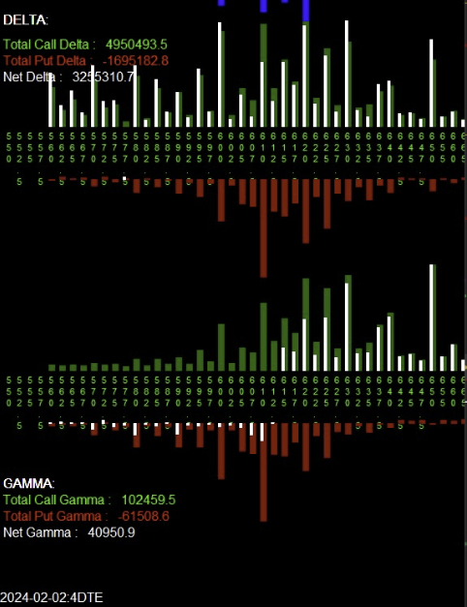

IV Skew

X Axis is the Strike Prices, Y Axis is the IV Skew Vol

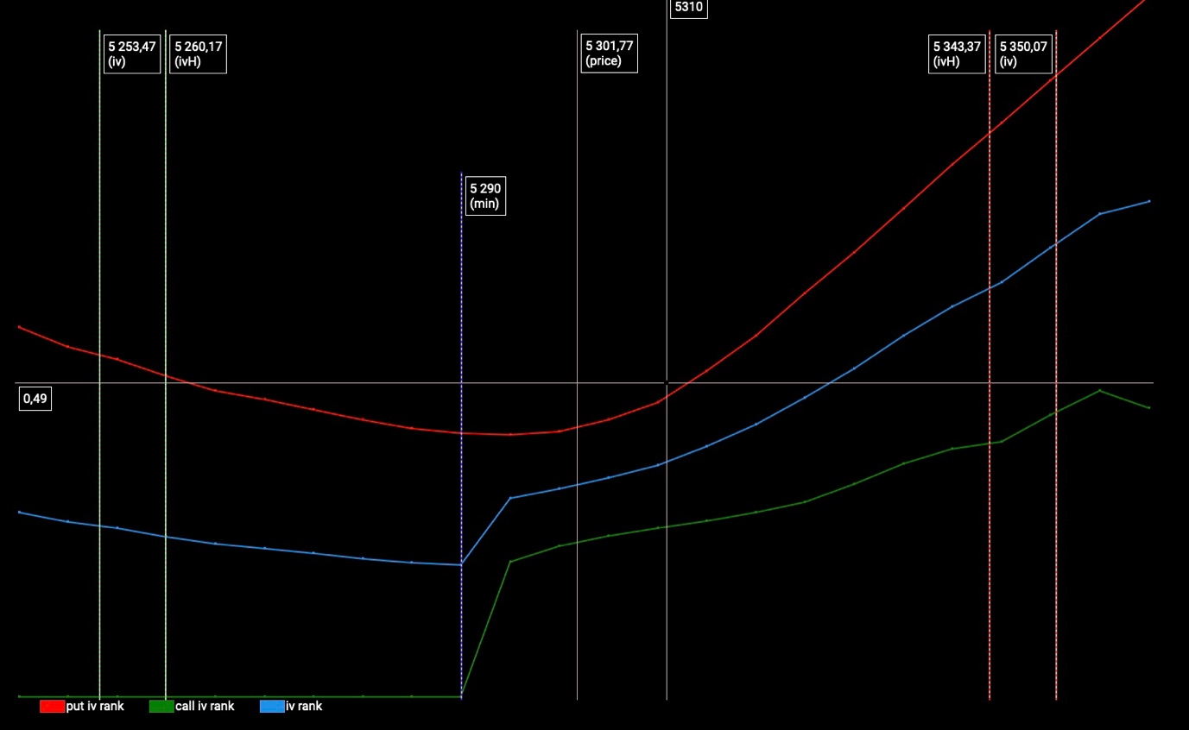

Calculations

Call Gamma Exposure = Gamma \* Open Int \* 100

Put Gamma Exposure = Gamma \* Open Int \* -100

Call Delta Exposure = Delta \* Open Int \* 100

Put Delta Exposure = Delta \* Open Int \* 100

Call Hybrid Exposure = (Gamma \* Open Int \* 100) + (Delta \* Open Int \* 100)

Put Hybrid Exposure = (Gamma \* Open Int \* -100) + (Delta \* Open Int \* 100)

Call Vega Exposure = Vega \* Open Int \* 100

Put Vega Exposure = Vega \* Open Int \* -100

Net Delta Exposure = All call delta exposure + all put delta exposure

Net Gamma Exposure = All call gamma exposure + all put gamma exposure

\*\*Note: Highlight in yellow are to be shown in via chart format as shown above, highlighted in blue to be shown as values only.